Module 4-Linux

Assignment

- Creating and Renaming Files/Directories

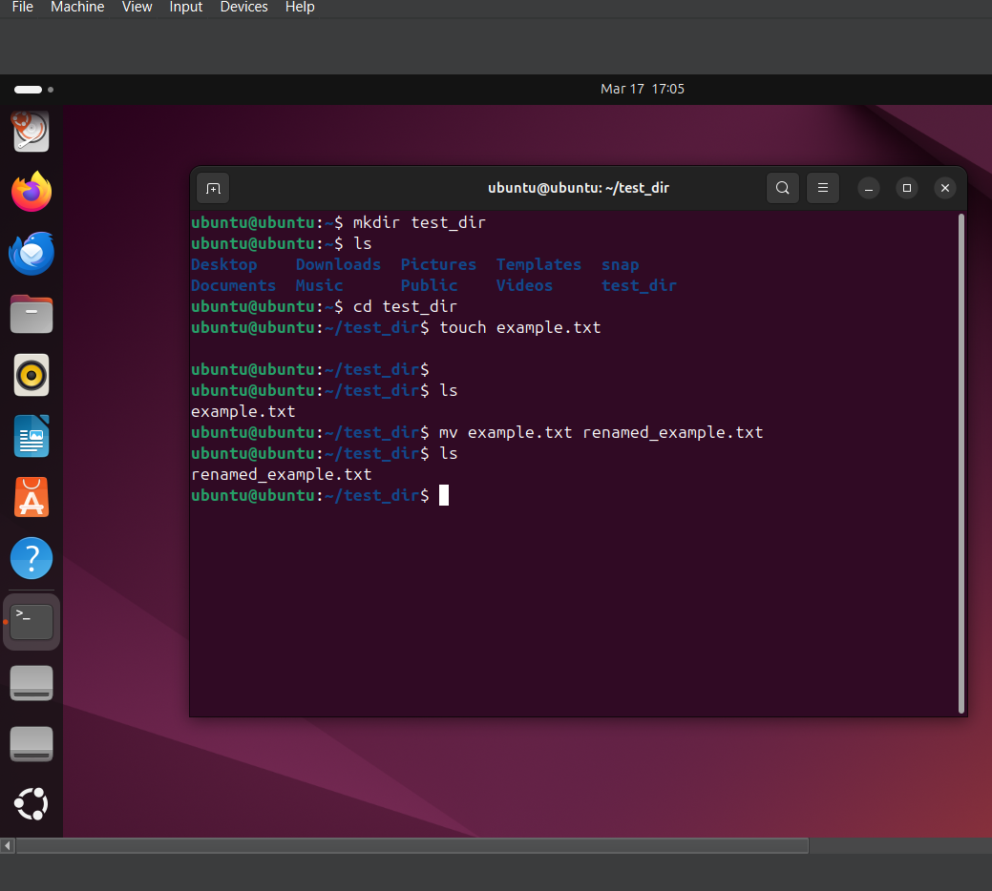

In this question 1 , we are ;
Creating a directory using Linux command ‘ mkdir’
Creating a file inside it using Linux command ‘touch’
Renaming it using Linux command ‘mv’

2. Viewing File Contents
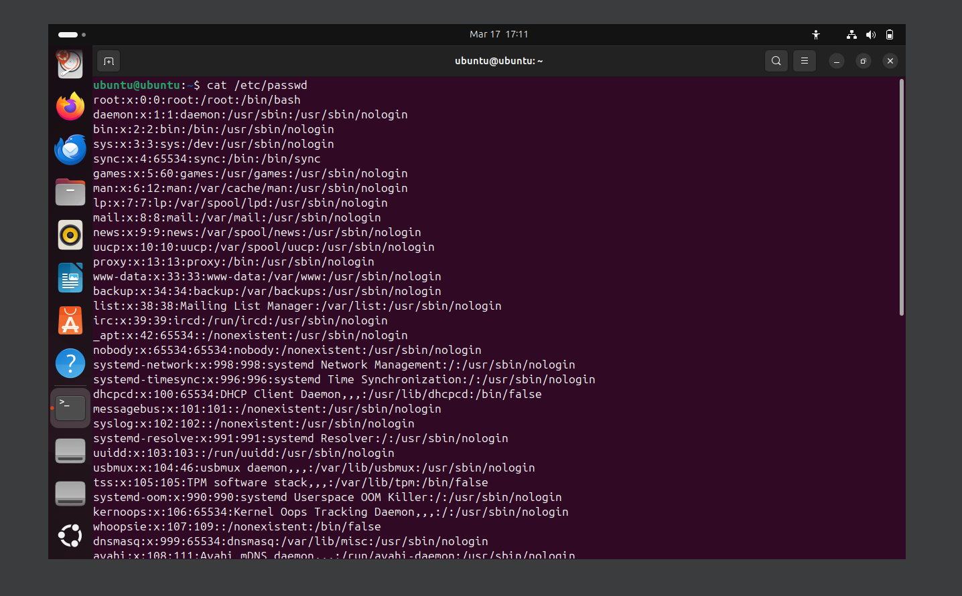

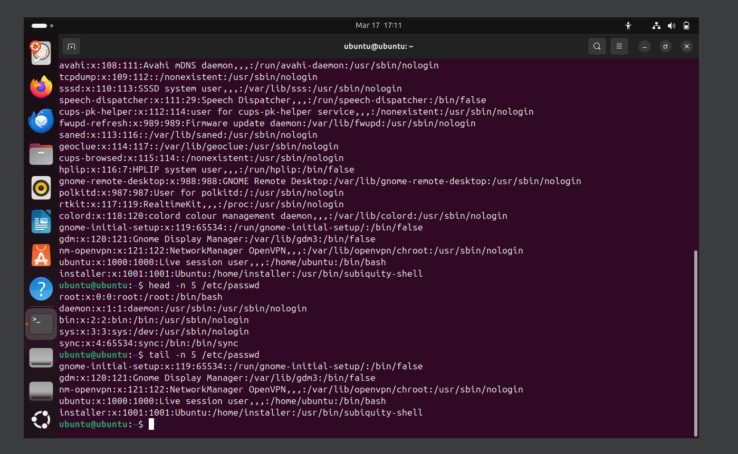

In this question 2, we are:
Using Linux command ‘cat’ to show full content
Using Linux command ‘head’ to show first five lines
Using Linux command ‘tail’ to show last five lines

3.Searching for Patterns
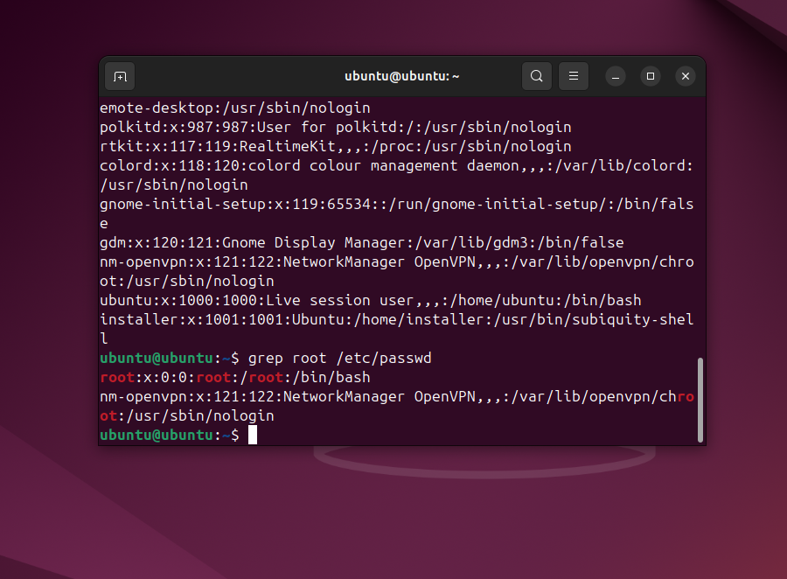

In this question , we are:
Using Linux command ‘grep’ to find the a word(root) in the file

4. Zipping and Unzipping
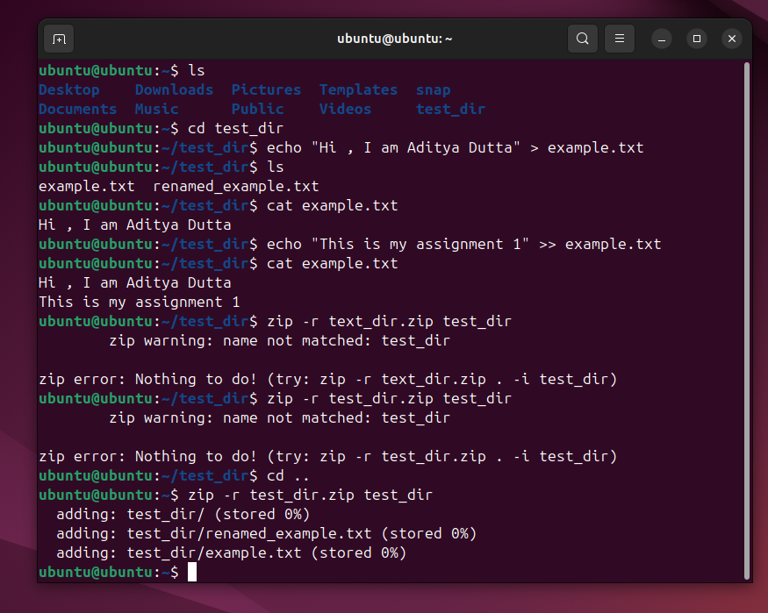

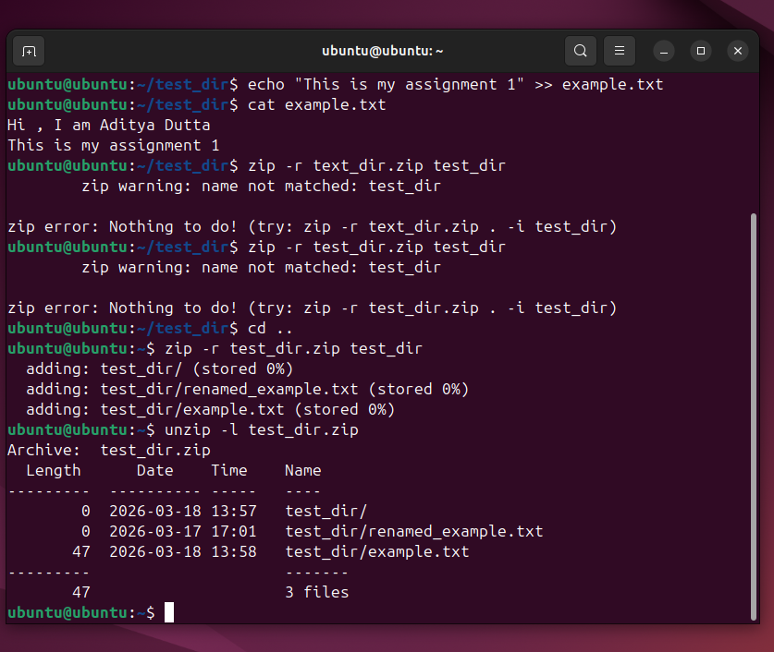

In this question ,we are :
We have compressed and extracted a directory using Linux command ‘zip’ and ‘unzip’

5. Downloading Files
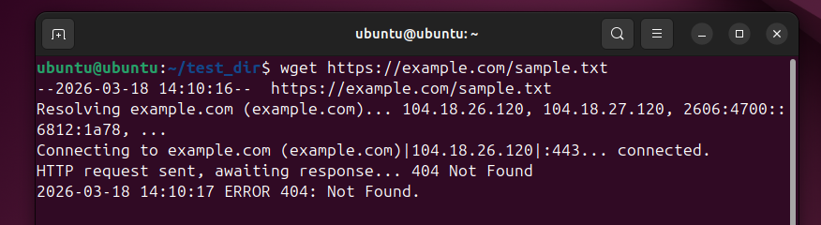

In this Question, we are:
Downloading a file from the internet using the Linux command ‘wget’

6.Changing Premission

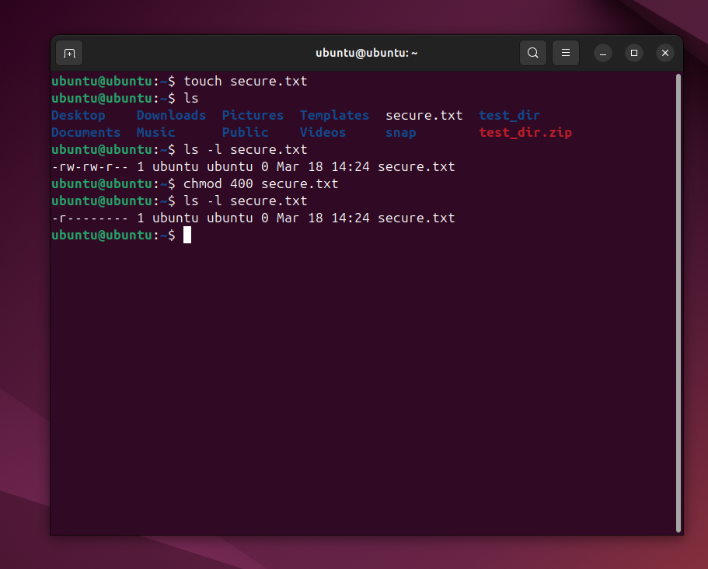

In this question,we are :
Changing the file permission using the Linux command ‘chmod’

- Working with Environment Variable
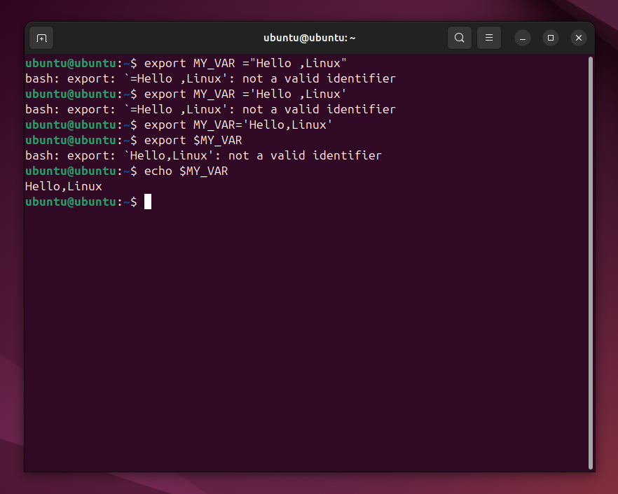
In this question ,we are:
Creating the environment variable using Linux command ‘export’

